Seminar Report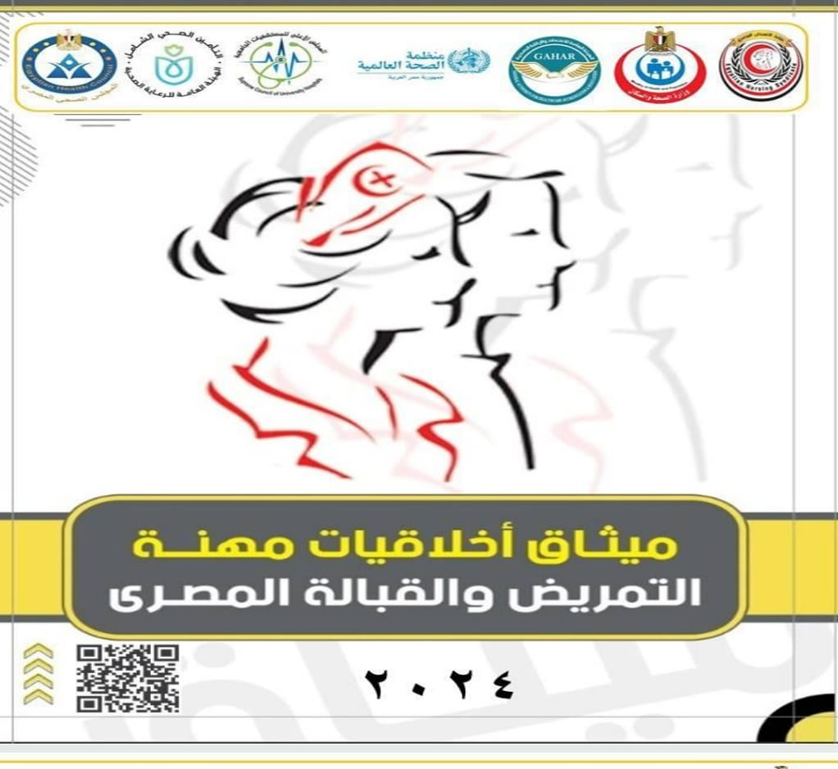

Under the Patronage of:

Prof. Dr. Abeer Abdel-Fattah Mahmoud, Dean of the Faculty of Nursing, Damanhour University.

Prof. Dr. Amal Awad Mousa, Head of the Department of Psychiatric and Mental Health Nursing.

On Thursday, October 16, 2025, a seminar was held under the title:
“Introduction to the Ethical Code of the Nursing and Midwifery Profession in Egypt”
The seminar was delivered by Dr. Walid Mahmoud El-Sharnouby, Demonstrator at the Department of Psychiatric and Mental Health Nursing.

This event was organized within the framework of the faculty’s commitment to promoting professional values and instilling ethical principles among its students, in order to prepare nurses who uphold high standards of responsibility, professionalism, and adherence to exemplary ethical conduct.

The seminar took place in Lecture Hall (3) at the Central Laboratories, Scientific Complex, Damanhour, with the attendance of 100 fourth-year students and 5 faculty members.

During the session, the concept of the Nursing Ethical Code was introduced; highlighting its importance in establishing trust between the nurse and the patient, its role in enhancing the quality of healthcare services, and the core principles it is based upon, including respect for patient privacy, maintaining confidentiality, teamwork within the healthcare setting, and adherence to professional and humanitarian responsibility.

At the conclusion of the seminar, emphasis was placed on the application of the ethical code in daily clinical practice and professional settings, serving as a guiding framework for nurses’ behavior and decision-making across different healthcare environments.
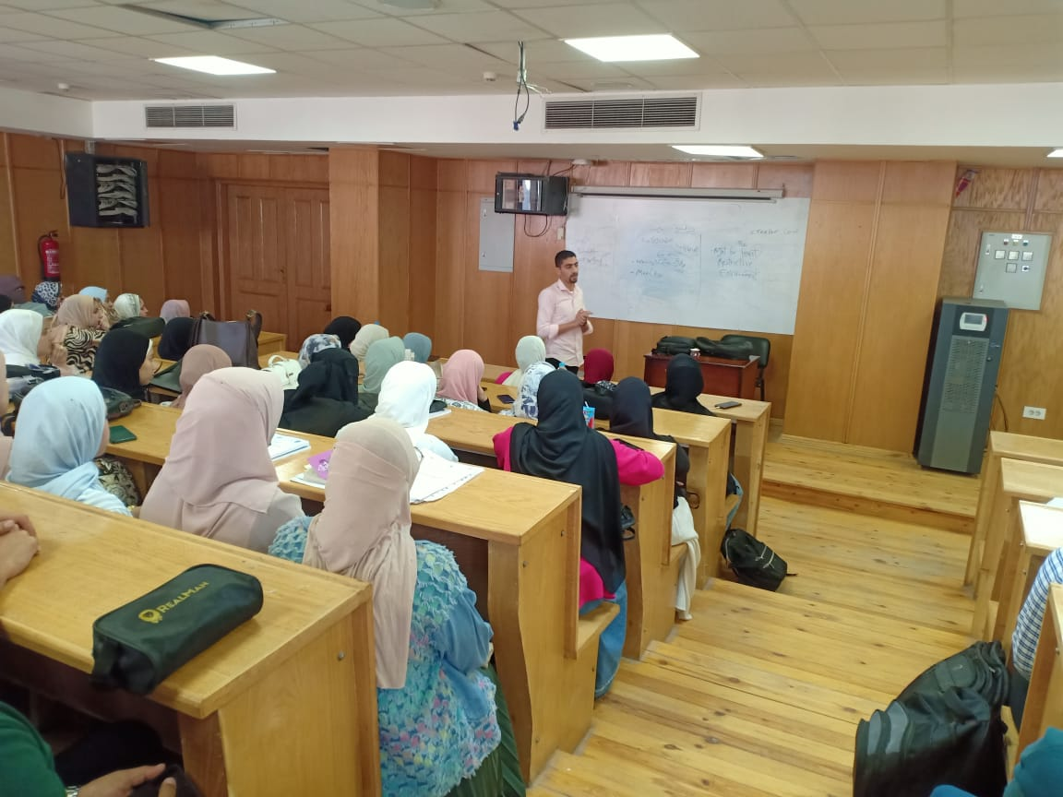
Prof. Dr. Abeer Abdel-Fattah, Dean of the Faculty, affirmed that such activities are part of the faculty’s strategic plan to instill professional values in nursing students from the outset of their academic journey, thereby preparing nursing graduates capable of fulfilling their mission with excellence and humanity.
